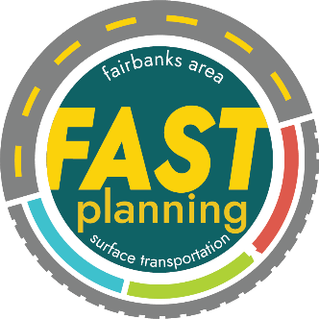

Call for Project Nominations
Publicly Accessible Electric Vehicle Charging Stations
Fairbanks & North Pole
Fairbanks Area Surface Transportation Planning (FAST Planning) is pleased to announce a new Call for Project Nominations for Publicly Accessible Electric Vehicle Charging Stations in Fairbanks and North Pole. A total of $2.4 million is available through a combination of Congestion Mitigation & Air Quality (CMAQ) and Carbon Reduction Program (CRP) funds. Priority for this funding in anticipated to be provided for publicly-owned properties since Federal funding is involved, but consideration may be given to private and non-profit entities who are willing to host a publicly accessible charging station(s) within the FAST Planning Area. Project nominations must also meet the following criteria:
- ADA accessible and publicly available for at least the hours of operation for the site
- Level 2 or 3 (DC Fast) charging station within a minimum of four ports
- Meet Build America, Buy America requirements
- Remain networked and operational for at least five years
- Commitment to pay a 9.03% match for the total project cost
Additional frequently asked questions (FAQs) are attached. FAST Planning’s Technical Committee will score and rank all nominations received, and awards will be made by FAST Planning’s Policy Board. Provided the funding source is Title 23 federal funds, the Alaska Department of Transportation & Public Facilities (DOT&PF) will manage the design and construction phases of awarded projects. Once installed, a public or private contractor(s) will be responsible for operation, maintenance, and submitting charging data on a quarterly basis.
Applications can be found online at https://fastplanning.us/evplan/ for the following information:
- Entity and applicant contact information
- Project description, including type of charging station(s), anticipated use/users served, and any site amenities for users to access while charging their vehicle
- Figures showing project location and site layout for proposed station(s)
- Understanding of site infrastructure needs, including utility improvements
- Safety considerations, including ADA accessibility, security, and site illumination
- Cold climate design considerations and any other known risks identified
- Commitment to operation and maintenance requirements, or if the site host intends to rely on a third-party contractor to meet requirements
- Documentation of preliminary commitment to paying 9.03% non-Federal match
The Application Period is open October 6 to November 21, 2025. Applications should be submitted online. Questions can be directed to jackson.fox@fastplanning.us at FAST Planning or call (907) 205-4276.

